# Homework: ASP.NET Deployment in IIS

This document defines the homework assignments from the ["ASP.NET MVC" Course @ Software University](https://softuni.bg/courses/asp-net-mvc/). Please submit as homework a single zip / rar / 7z archive holding the solutions (source code) of all below described problems.

## Create a Web Site in IIS

Create a **new Web site in IIS**, at **HTTP**, port **8888**. **Deploy a static HTML page** holding the text "Hello from IIS":

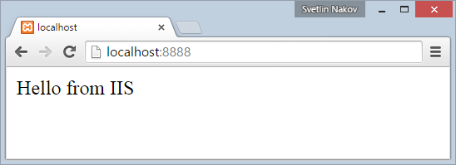

## Host a Site in a Domain

Create a **new local domain** entry in your local hosts file. The hosts file is used by the operating system to map hostnames to IP addresses, locally on your computer only ([learn more from Wikipedia](http://en.wikipedia.org/wiki/Hosts_%28file%29)). In Windows environment the hosts file is C:\Windows\System32\drivers\etc\hosts. In Linux, the hosts file is /etc/hosts. In Windows you might have not permissions to edit this file, so first copy it to your desktop, edit it, save the changes and finally replace it with the edited version.

Add the following line in your hosts file:

127.0.0.1 local.mycomputer.org

Create a new Web site in IIS, at HTTP, port 80, host local.mycomputer.org. It should open from your browser from this URL: <http://local.mycomputer.org>. **Deploy a static HTML page** holding the text "Hello from local.mycomputer.org":

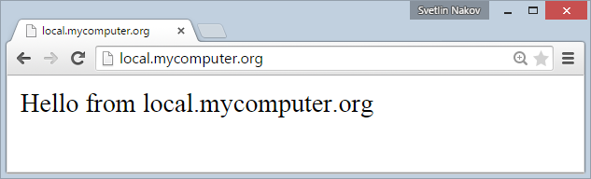

## Deploy a Data-Driven ASP.NET Web Application

Create a simple **ASP.NET MVC Web application** that uses a **SQL Server database**. You may use an existing application or create a new from scratch (e.g. create a new MVC app with authentication from the Visual Studio).

**Configure IIS** and **SQL Server**, **deploy your MVC application** at <http://local.mycomputer.org> and test it. Ensure the application correctly connects to the SQL Server database.

## Self-Signed SSL Certificate and HTTPS

Research how to **generate a** **self-signed SSL certificate** for the domain local.mycomputer.org and run a HTTPS binding in the IIS server to serve the URL <https://local.mycomputer.org>.

Note: The Web browser will warn you about the self-signed SSL certificate, this is normal.